Signs of Sunshine 5K Walk/Run and Kids Fun Run
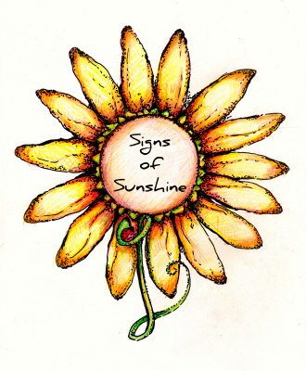
Saturday July 21st, 2012 - Maxwell Park – Normal, IL – 8 A.M.
RACE:
Accurately measured 5k course in the grass
Kids Fun Run (400 meters) - 12 and under @ 8 A.M.
5K Walk/Run @ 8:30 A.M.
One water stop during the race
Light refreshments provided
REGISTRATION / AWARDS:
5K Walk/Run fee: $20 – nonrefundable
First 100 to register before July 7th receive a t-shirt
Medals for top 3 male/female finishers
Kids Fun Run fee: $5 – nonrefundable
All kids fun run participants will receive a ribbon
CHECK-IN & RACE DAY REGISTRATION:
Maxwell Park Pavilion
7 - 7:45 A.M. for Kids Fun Run
7 - 8:15 A.M. for 5K Walk/Run
ABOUT SIGNS OF SUNSHINE:
We are a 501c3 non-profit organization working to create a better quality of life for individuals and families suffering from a serious injury or illness by providing the necessary equipment, support, assistance, and by promoting compassion in the community. For more information visit www.signsofsunshine.org
-------------------------------------------------------------------------------------------------------------
Send registration form(s) with check payable to Signs of Sunshine to: Jenny Baugh
Phone: (309) 830-6760 301 N. Bone Dr.
(309) 232-8679 Normal, IL 61761

EVENT (circle one): 5K walk/run ($20) Kids Fun Run ($5)
T-SHIRT SIZE: (5K walk/run only) S M L XL XXL(add $2)

NAME _______________________________________________________ AGE ______ SEX_________
ADDRESS____________________________________________________PHONE ___________________
CITY _______________________________________________ STATE _________ ZIP _______________
EMERGENCY CONTACT: NAME________________________________________ NUMBER____________
Upon accepting my application and in consideration of allowing me to enter this event, which I agree is at my own risk and entirely of my own free will, I hereby for myself and on behalf of my heirs, executors, and administrators hold harmless race sponsors, Signs of Sunshine, the Town of Normal, and others associated with this event from any responsibility or liability whatsoever for any losses, injury or any other damage sustained in any activities during or surrounding this event. I also understand my name and/or photograph may be used in conjunction with results or promotions by Signs of Sunshine.
Signature ________________________________________ Date_______________
Parent Signature needed if under 18

